Use-Case Realization Report (Design)
Delete Question

Issue <1.0>
Revision History
Date | Issue | Description | Author
<05/Oct/09> | <1.0> | <Initial version> | <Thomas Yap>

Table of Contents
1. Brief Description 4
2. Flow of Events 4
2.1 Standard Flow 4
2.1.1 Delete Question 4
3. Interaction Diagrams 5
3.1 Collaboration Diagram for Delete Question 5
3.2 Sequence Diagram for Delete Question 6
4. Participating Objects 6
5. Class Diagrams 7
5.1 Class Diagram for Delete Question 7
6. Derived Requirements 7

Use-Case Realization Report
Delete Question

Brief Description
This use case enables the controller to delete new questions to Question Pool. It involves displaying the menu and form and search by search strings or list to delete the record.

Flow of Events
The standard flow of events for this use case and any exceptions are described in the following subsections. The events are described in terms of Actors and Design Objects.

Standard Flow
This use case covers the Question Maintenance - Delete Question. The standard flows of these events are described below.

Delete Question
The running of the application is shown in section 3.1. The flow of event is as follow:

- When the application start, the first operation to be performed is the startup operation of the main controller. This operation will create all the control objects and the entity objects necessary for operation Delete Question:
  - The control object created is: MCQBL Controller
  - The entity objects create are: mcq_exam_master, mcq_section_master, mcq_question_master and mcq_question_option

- The main controller will start the main function menu:
  - To start Delete Question, operation load_page() is activated by MCQBL Controller to display a Question form.
  - PopulateObjectList() will retrieve a title list of question for Portal Admin to select to be displayed on form Question.
  - Upon confirmation by clicking the delete button, the record will then be deleted from table using operation deletequestion() and deletequestionoption().
  - The request can be cancelled by clicking cancel button and no data will be altered. A confirmation message will be displayed by form Question interface.

- Step 2 will be repeated until all deletions are completion. Then controller will terminate the application by issuing operation close.

Interaction Diagrams

Collaboration Diagram for Delete Question
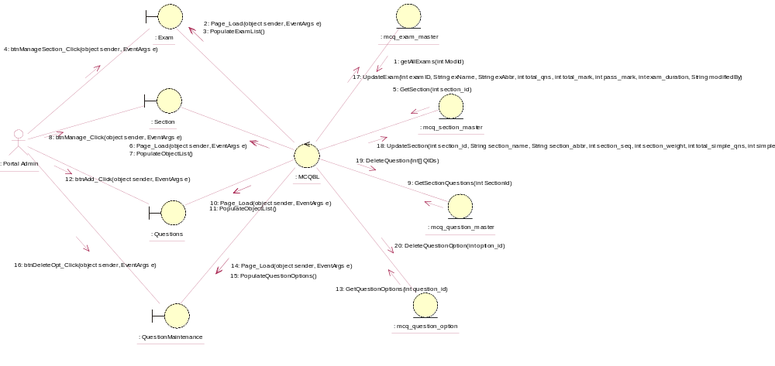

Sequence Diagram for Delete Question
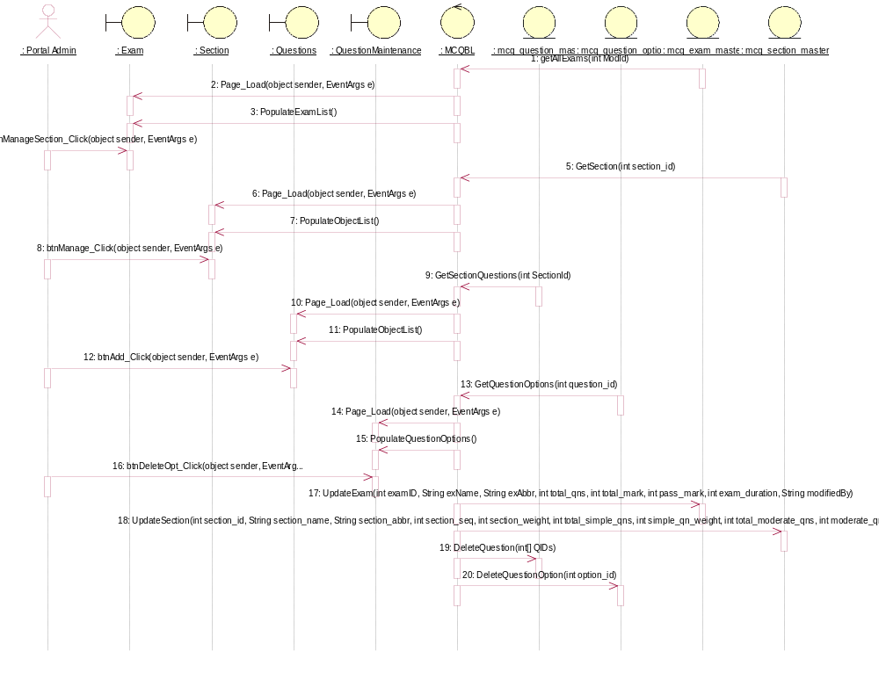

Participating Objects
: Exam

: mcq_exam_master

: mcq_question_master

: mcq_question_option

: mcq_section_master

: MCQBL

: Portal Admin

: QuestionMaintenance

: Questions

: Section

Class Diagrams

Class Diagram for Delete Question
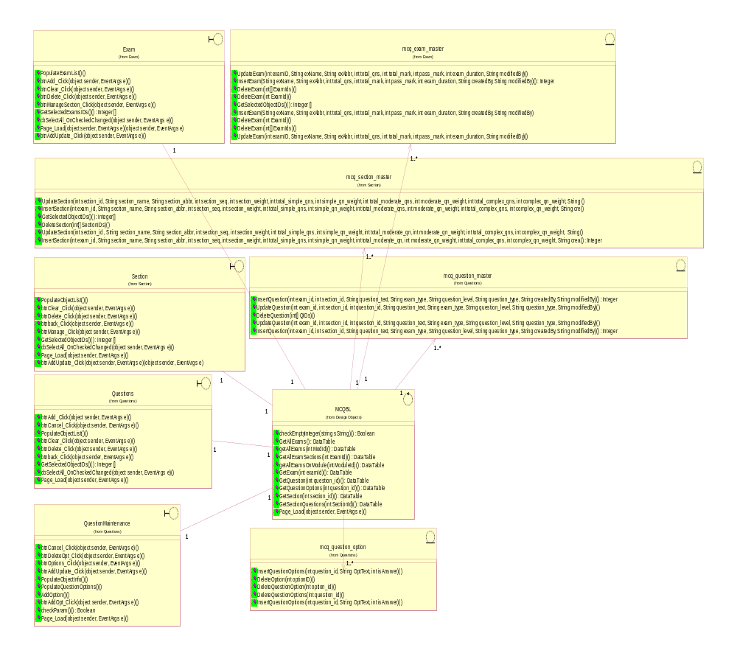

Derived Requirements
[enter the derived requirements here]

